**KENDRIYA VIDYALAYA CME PUNE-31**

* **MATHS GARDEN**

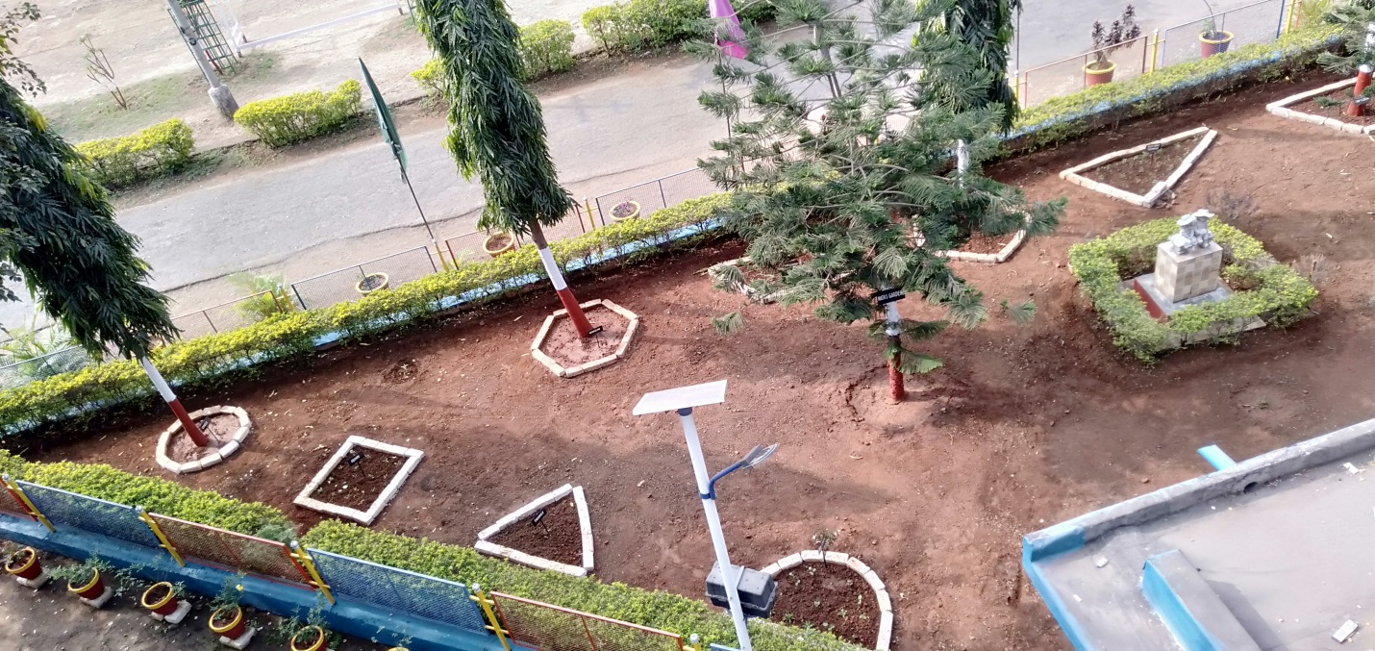

* **GARDEN**

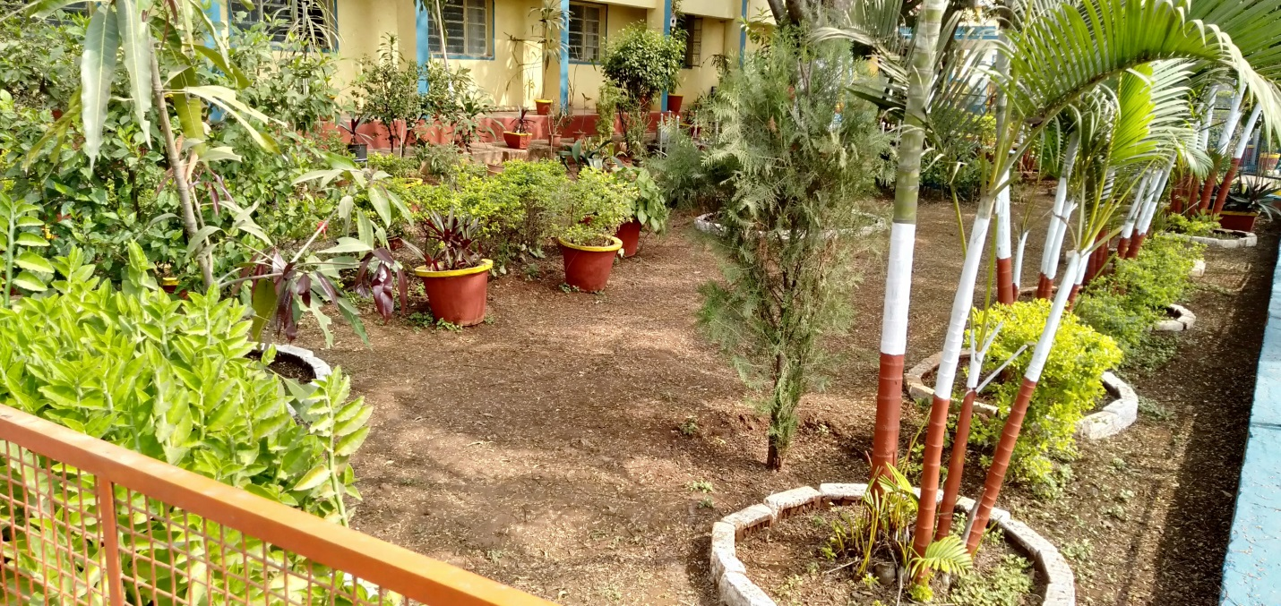

* **PLAYGROUND**

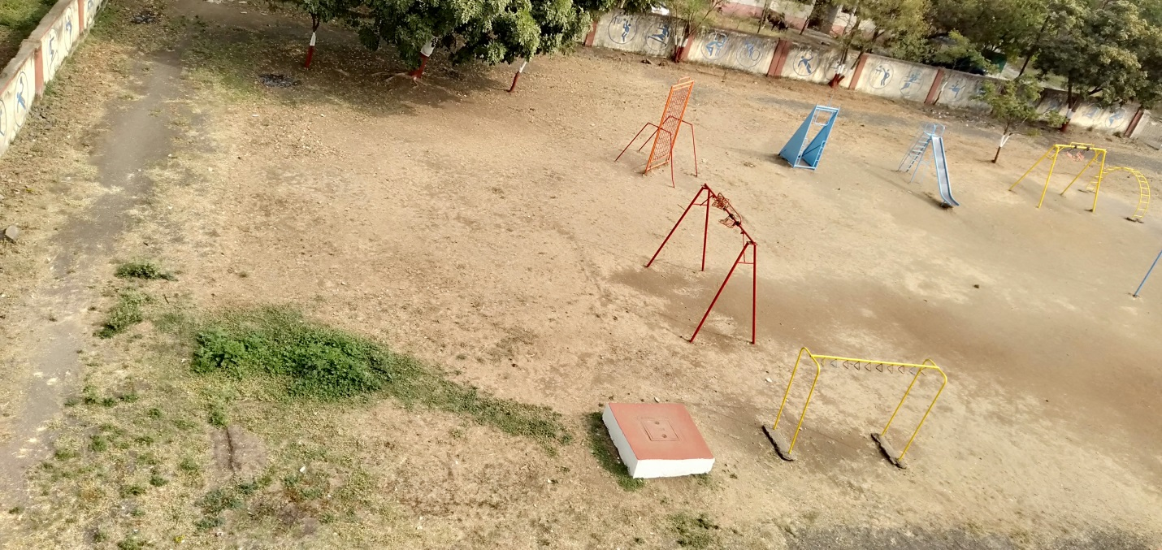

* **MATHS GARDEN**

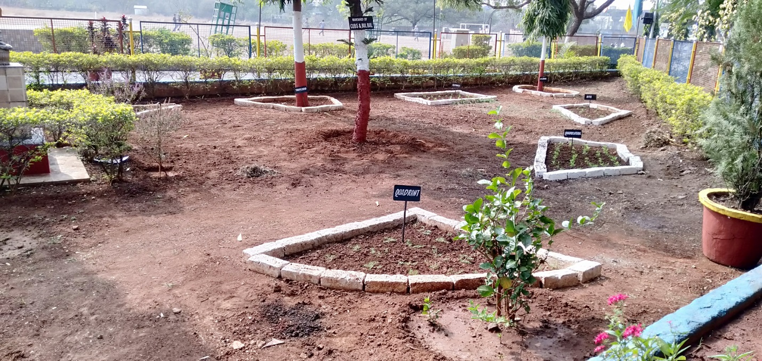

* **SCHOOL ENTRANCE**

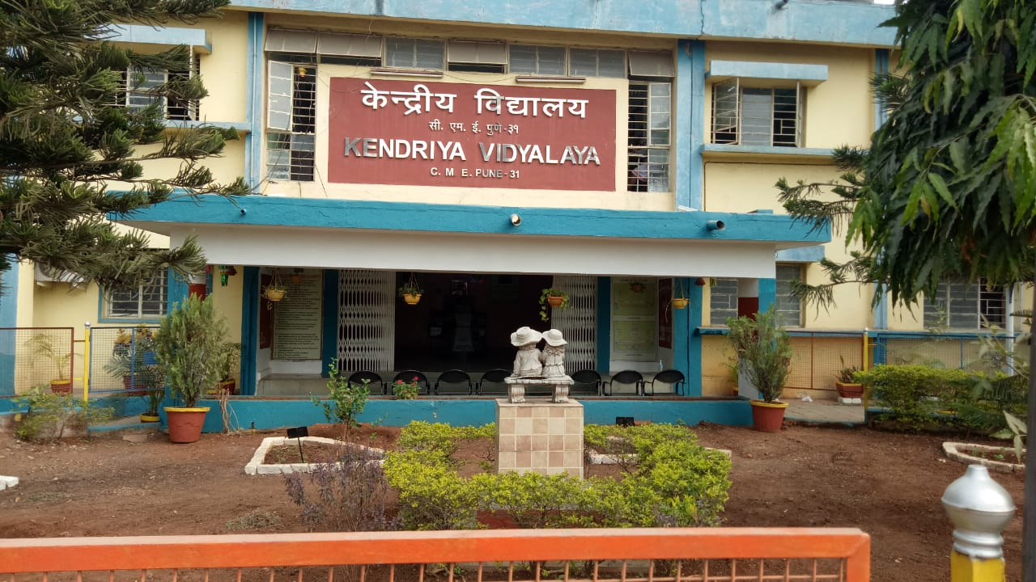

* **PARKING**

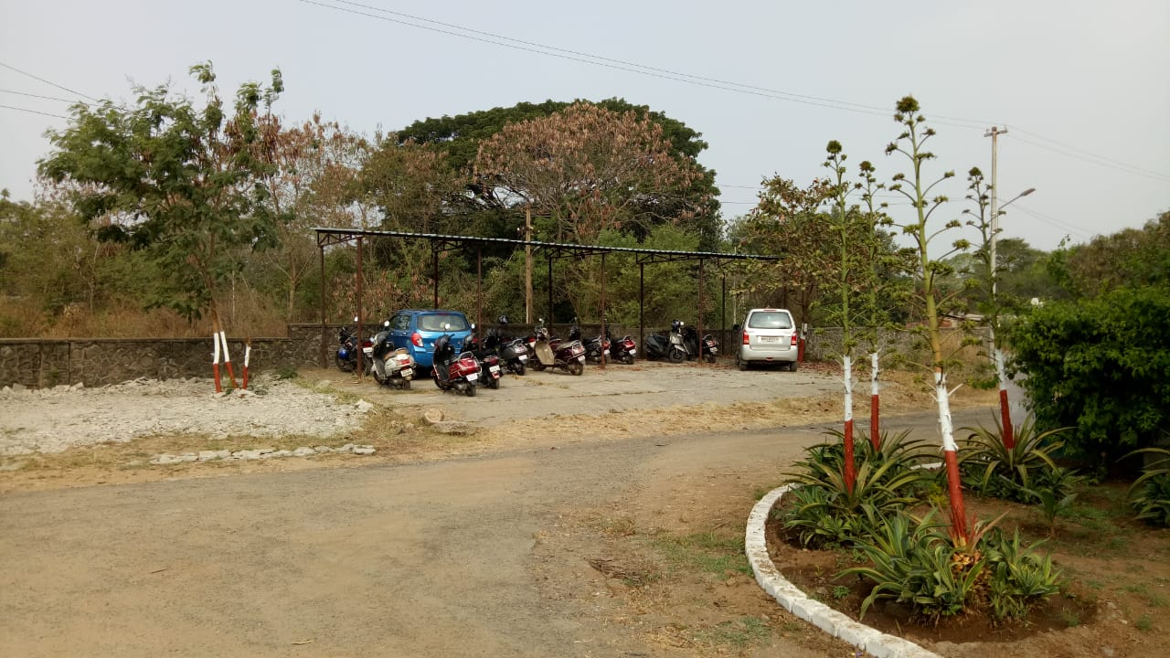

* **BASKETBALL GROUND**

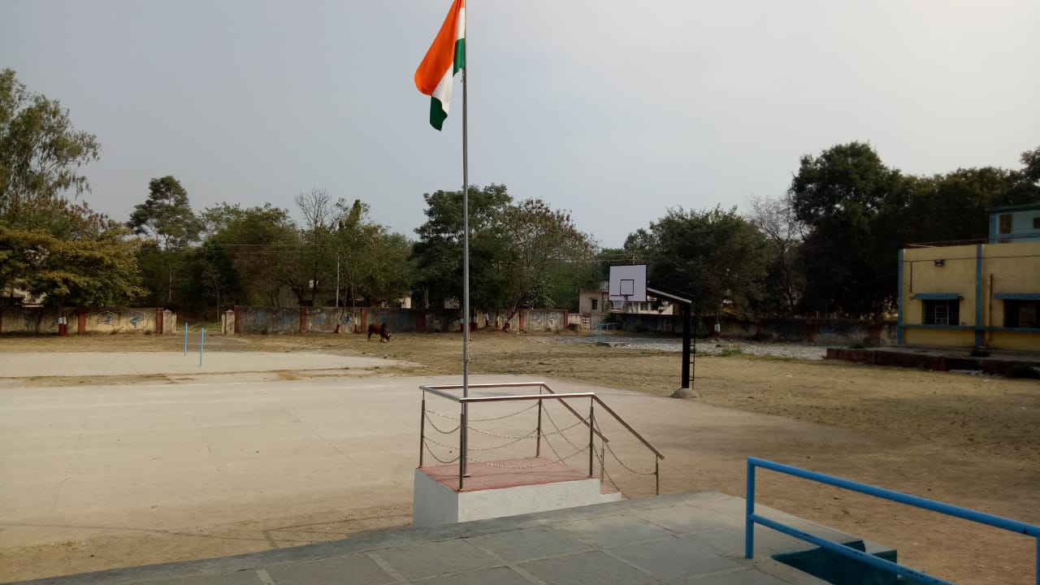

* **SMART CLASS**

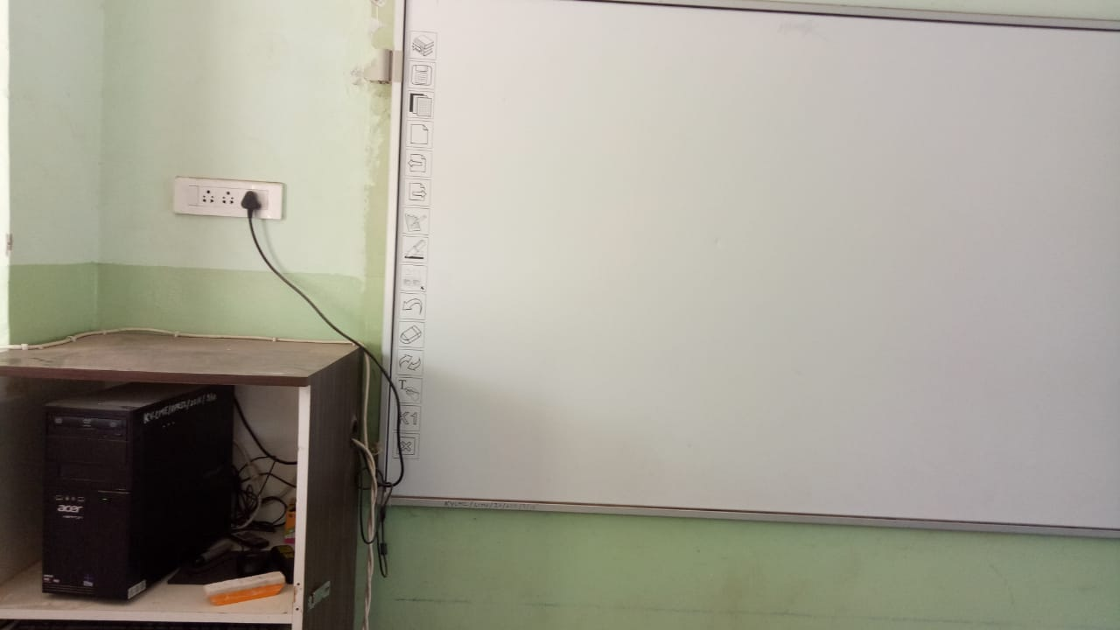

* **CONFERENCE HALL**

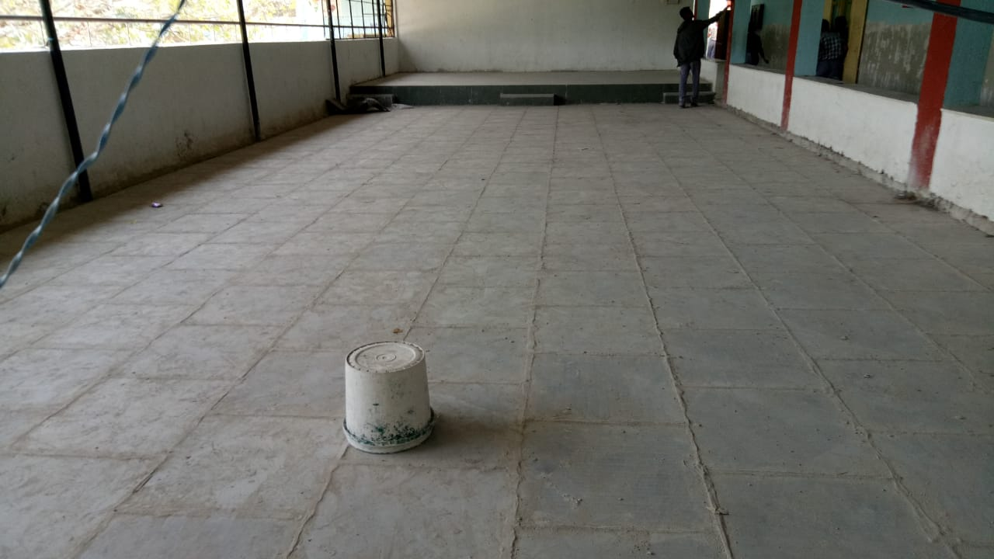

* **DRINKING WATER**

